Gen AI Data Analysis for Housingprices_New Datasheet

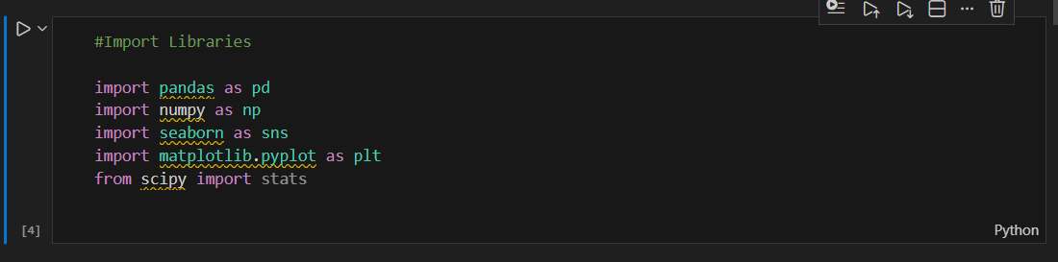
- Importing useful libraries

- Load Dataset, Display head data and information of columns
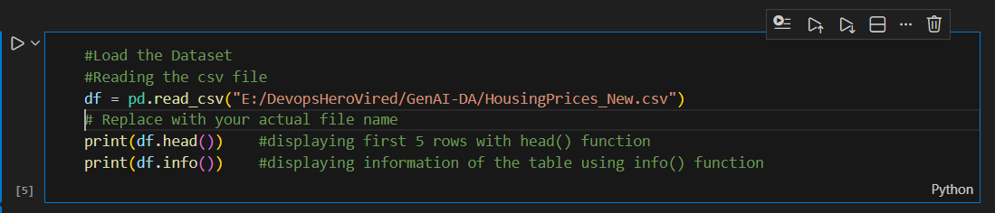

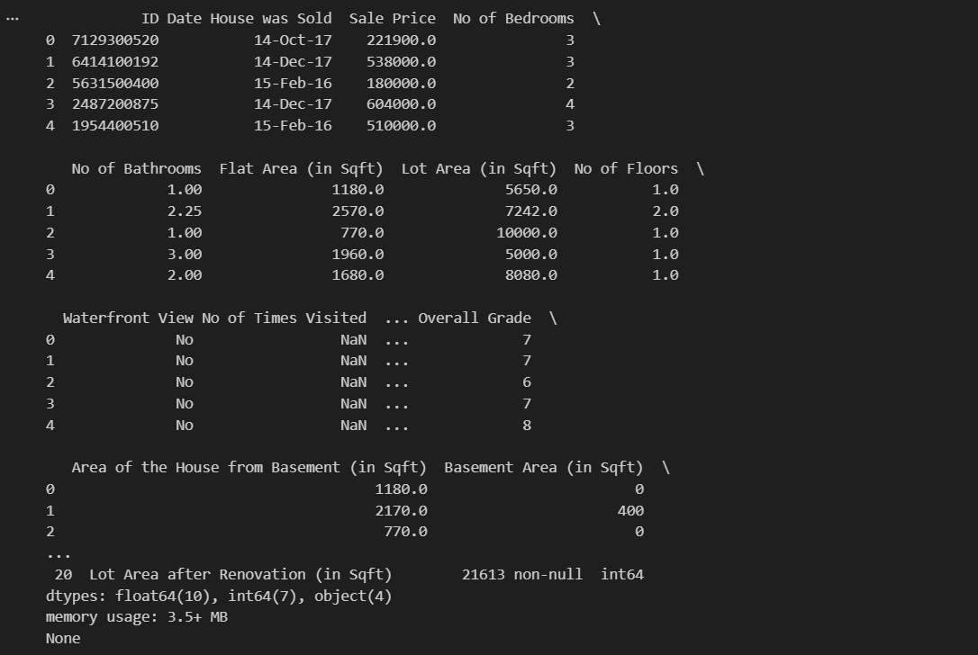

- Testing Missing Values and Heatmap Graph
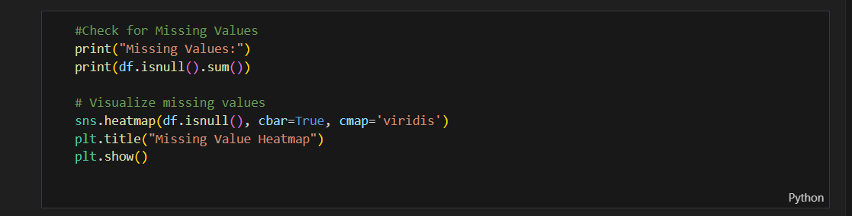

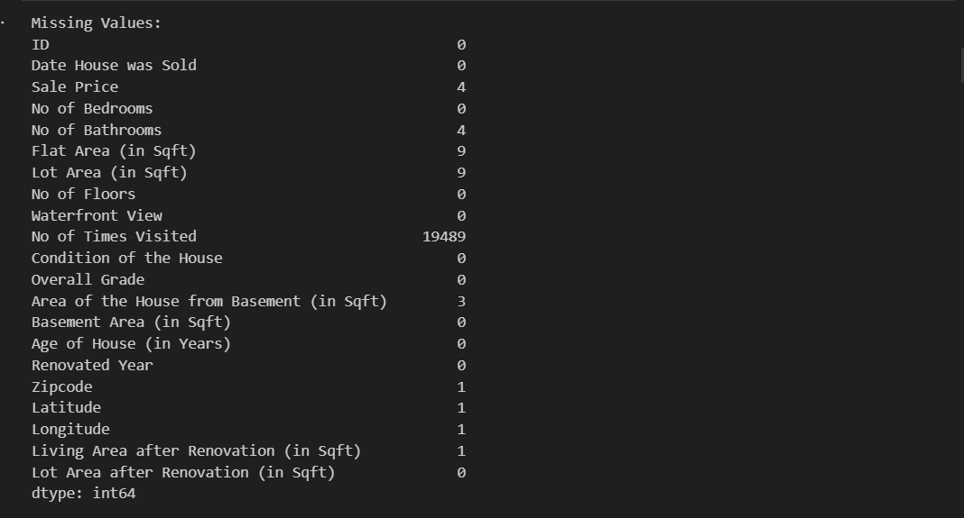

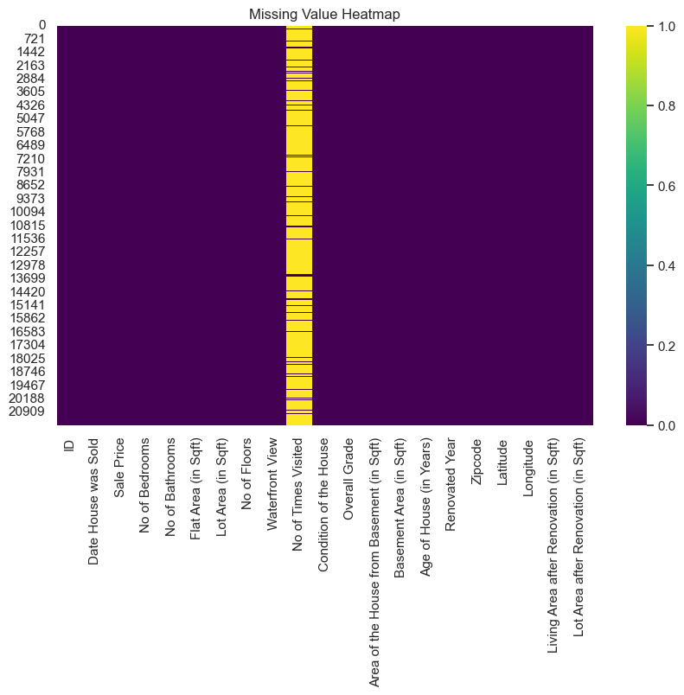

- Calculating Descriptive Statistics (Mean, Median, Mode etc.)
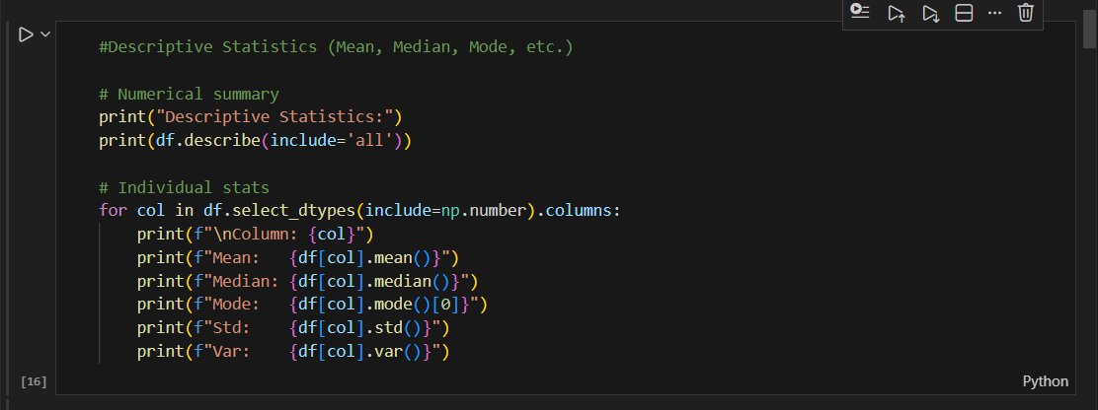

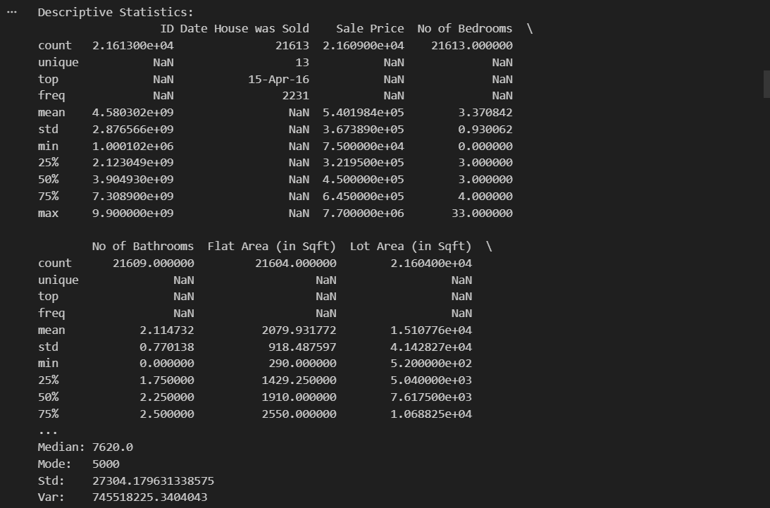

- Outlier Detection:

Note: Outlier count for each field is shown in python file for reference
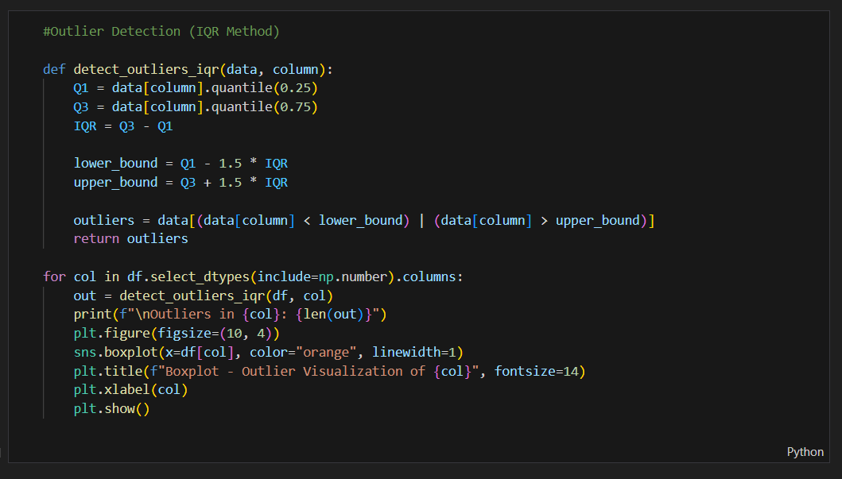

- Final Visualization (of all fields and correlation graph)
